

**SWE30010 - Managing IT Projects**

**TASK 12: Sprint 1 Review**

HUMAN RESOURCE MANAGEMENT WITH

ATTENDANCE SYSTEM

*Group 2*

**GROUP 2 INFORMATION**

| **Name** | **ID** | **Tutor** | **Class** |
| --- | --- | --- | --- |
| Le Hoang Hai | 103542974 | Thomas Hang  Nsam@swin.edu.au | Saturday  7:00 AM |
| Nguyen Dinh Nhat Minh | 103802490 |
| Nguyen Nhat Huy | 103802911 |
| Nguyen Ngoc Minh Thy | 103802791 |

**SPRINT REVIEW**

When we were defining the tasks for this sprint, we defined 20 general tasks, five for each of our sprint products. Initially, we thought that these tasks were sufficient, however as we developed our product, the scope of it expanded and we inevitably lost track of the tasks at hand and had to resort to creating smaller subtasks in order to keep track of our progress on the website.

These subtasks aren't listed in the WBS. However, our team has noted down the tasks they've gathered from their work independently (and they will be combined in the subsequent section). Therefore, we'll assess the completeness of our product based on both the items outlined in the WBS and those that aren't formally documented.

1. **Completed Items**
2. Research the overall design of current Gemadept’s system.
3. Create sitemap and navigation paths of the website.
4. Wireframe of the main page of the HRM website.
5. Design mockup of main page, employee manager, payroll manager, manager, reporting dashboard.
6. Design and implement a front-end using HTML, CSS, and JavaScript frameworks.
7. Set up a back-end system to handle user authentication, database. interactions, and business logic.
8. Implemented Authentication and Authorization on the website.
9. Added middleware for API security, crypto hashing and salting for authentication.
10. Conduct usability testing.
11. Conduct front and back-end testing.
12. Identify and prioritise the key entities in the HR domain.
13. Define the attributes and data types for each entity based on the information to be stored.
14. Create an entity-relationship diagram (ERD).
15. Gather requirements from managers and stakeholders.
16. Create user stories or use cases to document the desired functionality of the portal.
17. Payroll module is completed ahead of schedule (scheduled for Sprint 2 but finished in Sprint 1)

**B. Incomplete Items**

Even though we were able to complete most of the website’s function:

1. **UI/UX**
2. Responsive design.
3. The reporting dashboard is generally incomplete.
4. Fine tune the UI code to make it closely align to the design mockup.
5. **System functionality**
6. Generate reports.
7. Align the database design to ERD.
8. Deep testing.
9. Mass email sending.
10. Register new accounts.
11. User role page access.
12. Real-time Notification, chatbox support.
13. Biometric system for attendance check.
14. Monthly mockup data for charts.
15. Normalise the database data, review and optimise the schema design.

**C. Rationale**

There are several reasons why we were unable to complete some of the items on time. One of them was the fact that we underestimated the sheer complexity of some of the tasks. For instance, the objective of Sprint 1 was to implement a base HRM website with some basic HRM operations. However, we severely underestimated the complexity of developing a website as there are many subtasks involved. This meant more time was needed to complete the task, delaying the completion of other tasks significantly. Another problem was that the task descriptions were too vague in the beginning. We learnt the hard way that we should have divided our tasks into smaller, more manageable portions to get better results.

In order to improve this, we would need to research the tasks at hand more thoroughly to be able to understand what needs to be done. With a clearly defined task, we can much more easily determine their complexity, the subtasks involved and have a more accurate time estimation. Furthermore, we should discuss our product and process with the tutor or other experienced personnel to gain insight into how feasible a task is.

**D. Suggestions for Improvement**

After the sprint review, our stakeholders requested for some adjustments to be made with the current project, including:

1. **User access management:** Users should only be able to access what is available to them, depending on their role.
2. **System improvements:** Improvements to design, control management, implementation of Captcha.
3. **DB improvements:** Transfer current database system (Google Sheets) to a proper one such as MariaDB or MongoDB.

**E. Appendix**

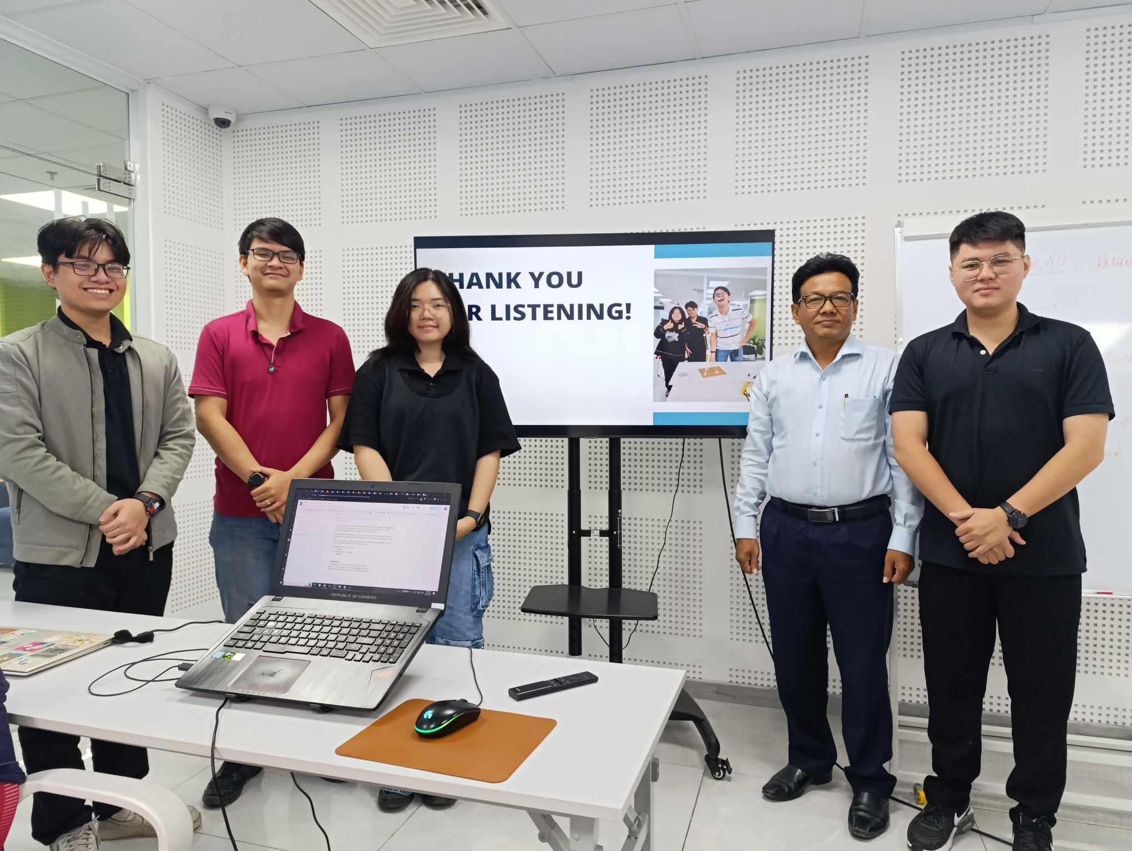

*Figure E.1: Our team’s sprint review presentation*